Project Phase I: Implementation Specification

*Versions 2.0*

CS/SE 6362 Advanced Software Architecture (Fall 2015)

**Submitted to:**

**Dr. Lawrence Chung,**

**Associate Professor,**

**Department of Computer Science,**

**The University of Texas at Dallas,**

**Richardson, TX -75080**

**Submitted By:** Team Name: Quick Search

**Sruthi Chappidi,** [**sxc105920@utdallas.edu**](mailto:sxc105920@utdallas.edu)**,**

**Barbara Maweu,** [**bmk101020@utdallas.edu**](mailto:bmk101020@utdallas.edu)

**Maryellen Oltman,** [**mco130030@utdallas.edu**](mailto:mco130030@utdallas.edu)

**Twinkle Sharma,**[**txs151730@utdallas.edu**](mailto:txs151730@utdallas.edu)**.**

**Team Website:** [**www.utdallas.edu/~maryellen.oltman**](http://www.utdallas.edu/~maryellen.oltman)

1. Methods Description

* Input { read( ), store( ) }

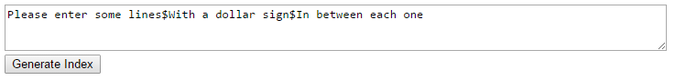

* Line Storage { setChar(int line, int word, int char, int value), char(int line, int word, int char), word(int line) }

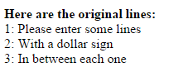

* Circular Shift { setUp( ), setChar(int shift_no, int word, int char, String value), char(int shift_no, int word, int char), word(int shift_no) }

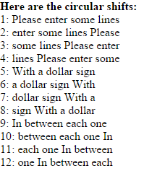

* Alphabetic Sort { setUp( ), alpha_sort(String[ ] list), line_ith( ) }

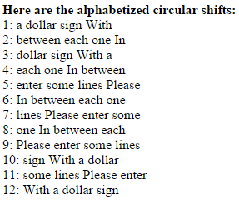

* Output {read( ), store( ), display( ) }
  + The output module’s implementation produces the above three module screenshots.

1. Prototype/ Screenshots

2.1 Implementation on Team Website (Version 1)

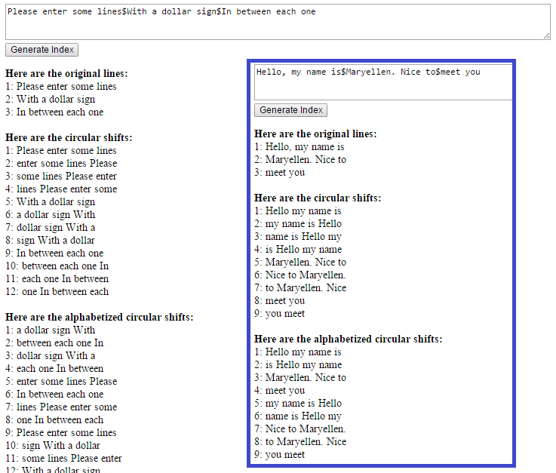

2.2 Prototype (Version 2)

